A.P.C. MAHALAXMI COLLEGE FOR WOMEN

MATHEMATICS DEPARTMENT

PROJECT TITLE:

Unlocking Insights into the Global Air Transportation Network

TEAM MEMBERS:

G.Mariya Vinciya

S.Sathiya Seeni Devi

A.Reshma

P.V.Parvathee

PROJECT REPORT

Unlocking Insights into the Global Air Transportation Network

1. Introduction:

1.1. Overview

This Global Air Transportation Network dataset is a comprehensive collection of information on airports, airlines and their routes. It contains information such as names, cities, countries, codes (IATA and ICAO) longitudes, latitudes and altitudes of airports across the world with detailed time zone and daylight saving time data. Additionally, this includes information about airlines including their IDs, name aliases, IATA and ICAO codes, callsigns country of origin and active/inactive status. Similarly, it also covers route details such as airline sources to destination airports along with essential details like codeshare stakeholder if any stops required during this journey along with the type of aircraft being used for that particular journey. This dataset has been compiled through meticulous labor by researchers all over the world to give you a comprehensive detail into air transportation networks from around the globe.

1.2. Purpose:

Allows people from different countries to cross International boundaries and travel other countries for personal, business, medical, and tourism purposes.

2. Problem Definition & Design Thinking

2.1. Empathy Map:

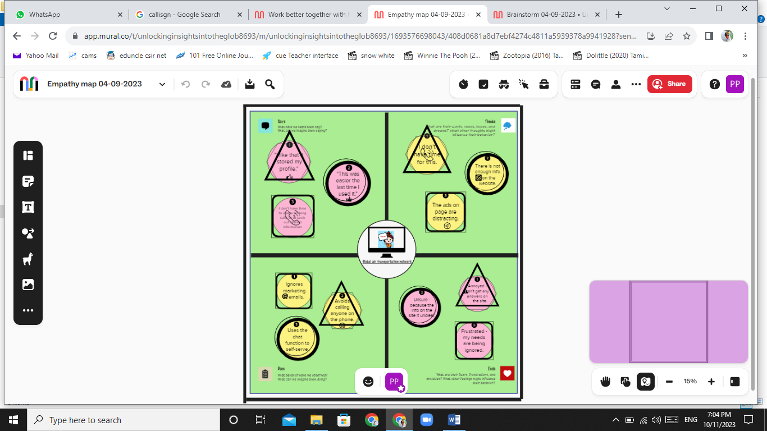

2.2. Brainstorm Map:

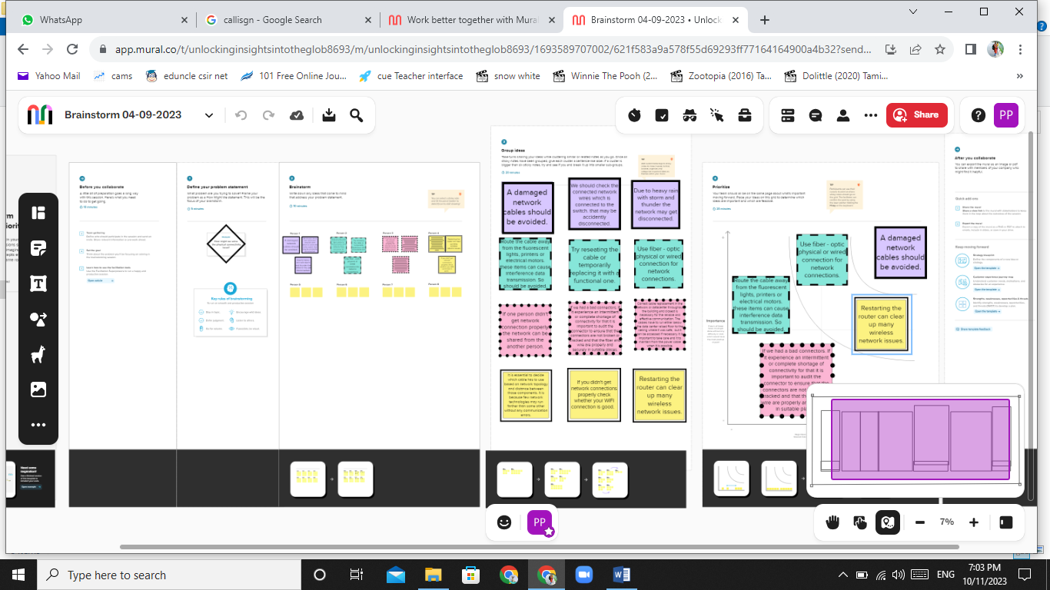

3. Result:

For our project we have used “Tableau” and completed a “Story” with a few “Dashboards” that gives out the information about the unlocking insights into the global air transportation network.









4. Advantages and Disadvantages:

Our Project can be used as a source of information be like High Speed. Air is the type of freight capable of travelling long distances in short periods of time and it gives the natural route.

This may cause risky also. It has Some Product Limitation. There is whole variety of materials not suitable for such products, from explosives, gases, batteries, fired solids and liquids, which cannot be shipped by air to name but a few. Compared to other means of travel, the risks of collisions are higher.

5. Applications:

Modeling air transport networks aims airline companies to organize their routes in a cost-efficient way and therefore maximize their profits. Air transport network models are also the tool to investigate system robustness. They help to determine weaknesses of the system in case of various kinds of disruptions. Once weaknesses are determined, a substitute node which can support all or part of the traffic load can be identified through the alternative strength for the pair.

An alternative application is modeling human disease networks. Air transport network is used by millions of people every day, therefore it plays key role in the spread of some infections, such as influenza or SARS. In this sense air transport network is a transmitter similar to sexual networks, which is liable for the spread of AIDS and other sexually transmitted diseases.

Allows people from different countries to cross international boundaries and travel other countries for personal, business, medical, and tourism purposes.

6. Conclusion:

As the industry continues to evolve, IATA will remain an important player in shaping the future of air transport. Conclusion, the International Air Transport Association has been instrumental in developing and improving the air transport industry

7. Future Scope:

In my point of you. Aviation provides the only rapid worldwide transportation network, generating economic growth, creating jobs, and facilitating international trade and tourism.